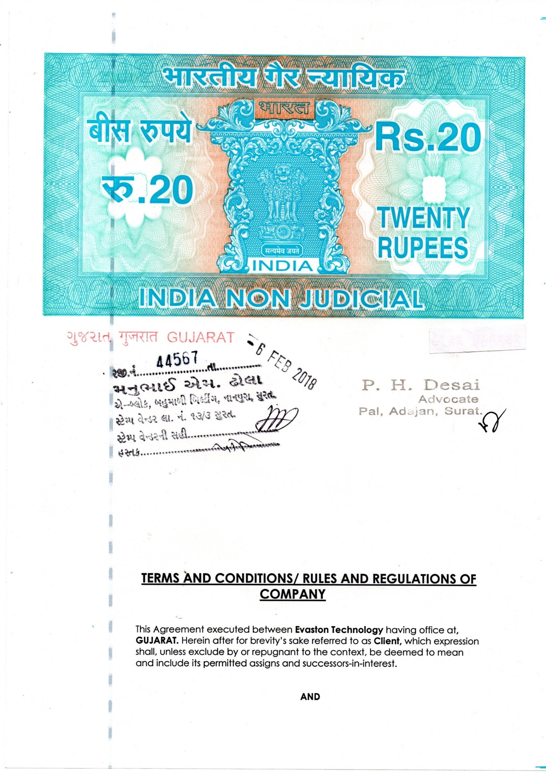

Mr. or M/s abhijeet namdevresiding at bandhan garden ke pass,dm-327 p.din dayal upadhyay nagar,indore,vijay nagar,madhya pradesh-452010Hereinafter for brevity’s sake referred to as “Business Associate”.) Which expression shall, unless excluded by or repugnant to the context, be deemed to mean and include its permitted assigns and successors-in-interest).
Whereas the Client is engaged in the business of outsourcing the business for the IT and IT enabled services industry and whereas it has entered into an agreement with its principals (herein after referred to as "Principals") to execute the data entry operations described in detail in the scope of work, which need to be executed through various delivery partners.
Presently it is in a position to procure the business for form filling more meaningfully described in the column Scope of Work, through their principals. AND WHEREAS the Business Associate is engaged inter alias, in the business of providing a wide Spectrum of software solutions & services. The Business Associate has acquired the necessary expertise and developed the requisite skill base and infrastructure for successful execution of Form Filling Projects.
This Agreement represents the business Agreement and operational understandings between the parties and shall remain in effect for a period of Twenty days from the date of execution hereof or from the date of providing the first data whichever is later & can be extended for the period as mutually agreed upon, for the purpose and as per the plan.
The Party of the Second Part chooses the plan as applicable more particularly described in detail in the Schedule attached herewith, representing to the Party of the First Part that the minimum Accuracy levels are guaranteed by way of a Performance guarantee.
NOW THIS AGREEMENT WITNESSETH AS FOLLOWS:

1.Scope of Work: The Original data will be available on the work environment software provided by Evaston Technologyat the time of signup. Business Associate is required to feed the provided data in the provided software as per the guidelines. Data supply and preservation of the output file is done online on real time basis.

2. Plan Details: - Second party will get 2000 forms for 20 days.
- No initial payment is required to be given by second party you must pay 5300/- amount for utility and maintenance.

2(b)In the matter of fact failure, not submittedorsucceed company is entitled to receive amount by any cost. If you pass then amount will be deduct from your work payment and if you fail then also you have to pay as a liability which describe in point no .2.

2(c) This charges related to service, development and maintenance cost of the platform where you working online.

3. Price: For the Form Filling services rendered by the Business Associate, they shall be entitled for payment of price 25 RS (INR) Max per form if the second party achieve the accuracy above 90.00%.

4. Payment: The Business Associate will get Q.C. report within 4-5 working days from the date of the submission in his own terminal.
The Client will make the payment for the billing within 7 INTERNATIONAL WORKING days from date of raising the bill subject to the quality check report.

5. Duration of the Contract: Contract period of this plan will be 1 work or slot for20 days.

6. Accuracy: Client must provide adequate feed back within 20 days for all data and on completion of quality check shall issue a quality report. Both parties agree to assure highest quality of end service. Following cycle for accuracy will be followed.

Cut Off Forms – 1800 (In Total)
Below Cut Off - ID Terminated. (i.e – 90.00%)
90.00% is the minimum requirement for further process.
In case, If you failed or could not submit work in a given time period then you have to pay a Utility Charges of 5300/- to company.

The Q.C. Department Will Show Only 4 To 5 Forms More Then Cut-Off Criteria and the Q.C. Department Will Check the From Randomly.
Till The Submitted Slot Is Rejected Above the Cut-Off Criteria
If customer makes any mistake in a form that form will be rejected, likewise client have to maintain cut off or accuracy.
The general principal of the work is that it should be done by any human being only.
If the company has doubt in your work/form filling project then the company will provide you 250 forms for verification in which you have to provide 90.00% accuracy and it will be for the duration of 2 days.

Technical clause:

- Helpline department will support you in only 10% queries from the whole project.
- For example: if you have taken the 1500 pages/forms plan, then helpline dept. is liable to give reply only 150 pages/forms queries of 10% of whole project.
- Work will automatically get Submit in 48 hours.
- No use of any shortcut keys while typing in terminal else you will be responsible for the same. For example: Tab Key, shit key & etc.

7. ID Allocation:- Business Associate will get single id to work on and business associate can work 24X7 on this id.
If company found that there are multiple logins of a single I.D., The company will not be responsible for the corruption of the data in both online modules. And your I.D. will get terminated without any intimation
If we find any 2 login together, 2 logout, 2 IP ADDRESS WITHOUT LOGIN, BROWSER UPGRADATION WITHOUT LOGIN, THEN THE ID WOULD BE TERMINATED.
After Delivering the report your Login id and password will get expire in 10 days.
If any kind of malfunctioning found in the work then company reserved the right to take trial of your work for a day.
If you break the company rules & regulation means your ID is get terminate company will not do any financial transaction to you.

If any default done by you with respect to payment of utility and maintenance charges on completion of 20 days. You will be liable for legal action civil as well as criminal.

8. TAT (Turn Around Time): The Second Party has 20 days (include holidays) to complete the New work and Second Party has to send it to First Party as per Plan. The First Party shall give an accuracy report within 4-5 working days.

9. Client agrees to provide formats and other information for processing the job to Business Associate at the time of providing the data.

10. Company is not responsible for Internet issue and related to the same, all the cost will be bear by the second party for the workload

11. Business Associate will execute the data processing work provided by Client through experienced persons in such manner so as to carry out the work efficiently at minimum of 90.00% accuracy for out files.

12. This agreement represents the business Agreement and operational understandings between the parties and shall remain in effect for a period of Twenty days from the date of execution hereof. The clients' specifications in terms of quality and other parameters that shall be issued by the Client/their principals from time to time and acknowledged by the Business Associate shall be read with this agreement.

13. Termination: - If Business Associate fails to submit data on time or, If Business Associate fails to give accuracy in output files. Client reserves the right to terminate the agreement with immediate effect. And Evaston Technologywill not be responsible for any further data and payment to the Business Associate.

14. No modification of the terms of this AGREEMENT shall be valid unless it is in writing and signed by all the parties.

15.Force Majeure: If the rendition of the Form Filling Services is hampered due to earthquake, flood, tempest, civil riots or Act of God then the Business Associate shall be absolved of its obligations hereunder till normalcy is restored after the cessation of the aforementioned contingencies. The Business Associate shall likewise be absolved if rendition of the services is hampered due to a strike
called by the date entry operators engaged by the Business Associate, violence or political turbulence or for any other reason of a similar nature, which is beyond the control of the Business Associate.

16.Severability: Unenforceability of any provision of this Agreement shall not affect any other provisions herein contained; instead, this Agreement shall be construed as if such unenforceable provision had not been contained herein.

17.Variation: Except as otherwise expressly provided in this Agreement, this Agreement may not be changed or modified in any way after it has been signed, except in writing signed by or on behalf of both of the parties.

18.Dispute Resolution & Jurisdiction: In the event of any dispute or difference arising between the parties hereto relating to or arising out of this Agreement, including the implementation, execution, interpretation, rectification, validity, enforceability, termination or rescission thereof, including the rights, obligations or liabilities of the parties hereto, the same will be adjudicated and determined by arbitration.

The Indian Arbitration & Conciliation Act, 1996 or any statutory amendment or re-enactment thereof in force in India, shall govern the reference. Both parties shall appoint their respectivearbitrator, and both arbitrators thus appointed should appoint the third Arbitrator who shall function as the presiding Arbitrator. The venue of arbitration shall be SURAT (GUJARAT). The Courts in the city of SURAT shall have exclusive jurisdiction to entertain try and determine the same. If business associate fail to provide us service charges then company is entitled to take legal step onwards.

19. Both the parties hereby agree neither to Circumvent or nor to disclose the identities, Information as well as the essence of the project etc of each other’s/Principals, clients etc to any other Third party and neither of us will approach each other’s contracts as identified from time to time.

Important contact details for work:

EMAIL:
- Submit the work at helpline.evaston@gmail.com
- Need help online mail at helpline.evaston@gmail.com
- Need to talk about Accuracy Report email at helpline.evaston@gmail.com
- Documentation Id at agreement.sspl2@gmail.com

PHONE NUMBERS:

- Helpline Number: 7211180153 // 7624098289
Helpline clause:

- You can mail us for helpline per day 3 emails ,& 1 email = 5 attachments only. & you’ll get reply into 24 working hrs. ( Holidays doesn’t include in that )

IN WITNESS WHEREOF the parties hereto have executed these presents on the date hereinbefore written: abhijeet namdev
Client: Business Associate:
For,Evaston Technology For, abhijeet namdev

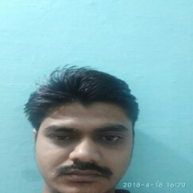


Authorized Signatory as Per Digital Signature Acceptance Attached




