


Samsung House,

1000 Hills wood Drive,

Chertsey, Surrey, KT16 0PS

TEL: +44 (70) 10039029

MAKE SURE YOU REPLY TO THIS E-MAIL ID SAMSUNG2018UK@outlook.com

SAMSUNG2017UK@outlook.com



Ref: SAM.625/11.16.003/2018

Dear Lucky Winner RAMASAMY .P,
We wish to congratulate you once again on this note, for being one of the winners selected in the Samsung Lottery Promotions, We are proud to inform you that, Your certified winning parcel containing a cheque of £500,000.00 (FIVE HUNDRED THOUSAND GREAT BRITISH POUNDS) and a 52 inch Widescreen Plasma TV with Built-In Home Theater System from Samsung Electronics, One Laptop, latest Samsung Phone, latest Samsung laptop,2 Samsung T .Shirt, prize winning Certificate and some other documents has been registered with this company which is to be delivered to your residence as instructed by.( Samsung Seasons Promotions United Kingdom ).In respect of your fund, we wish to inform you that Samsung Award board of directors has approved the delivery of your winning prize of £500,000.00,that was deposited in our company here in London by SAMSUNG LOTTERY PROMOTION board to be delivered in your home address in your country by our Bank Representative (Mr. Bishop Jeff).
We are pleased to inform you that a demand draft of £500,000.00 has been issued in regards to your name and will be dispatched to your designated home address within the next 48 hours. By Bank Representative Mr. Bishop Jeff, He will be arriving in your country India on the 12th day of February, 2018. You are required to provide a scan copy of your identity card that is acceptable in your country, that will enable our delivery officer verify you as the rightful owner of the cheque.
Your winning consignment box contains all of the following items:
1.) Your Winning Prize of (£500,000.00) (FIVE HUNDRED THOUSAND GREAT BRITISH POUNDS)
2.) 52 inch Widescreen Plasma TV with Built-In Home Theater System from Samsung Electronics
3.) Official Winning Certificate.
4.) Affidavit of claims eligibility.
5.) Documents covering source of winnings.
6.) Latest Samsung Smartphone
7.) Latest Samsung laptop and 2 Samsung T .Shirt.

UK Departure Date: 11/02/2018 Sunday {Departing Time 10:45pm}
India Arrival Date: 12/02/2018 Monday {Arriving Time 8:30am}
Note: All courier charges has been duly paid over here in UK WHILE you will be responsible for any local charges to be incurred by the diplomat in delivering your winning prize to you in your country.
Please be warned: you are advised to keep your winning information confidential from general public, we do not allow customers to send their friends or relatives to pick-up their parcels on their behalf due to security reasons.
SAMSUNG AWARD COMPANY parcel delivery has gone through a transformation from a mere quoting method to becoming an essential tool for shippers, entities who perform projections and inspections, and the general public We make it simple. By standardizing the Samsung Board delivery service of rates, hence Samsung Board parcel deliveries has put the world in your fingertips. We are not a broker, we are licensed by the Federal Maritime Commission as a non-vessel operating common carrier ( N.V.O.C.C.) to produce original shipping documents, and we are licensed by the Federal Aviation Administration under the TSA as an indirect air carrier (I.A.C.) to engage in air cargo worldwide, therefore we can leverage our technology with our experience to save your money and serve you on a global basic.
NOTE: you are to bare the payment of the custom clearance charge of your winning parcel at the international airport where he will arrival AND You are highly requested to cooperate with our Bank Representative (Mr. Bishop Jeff), to enable you has a smooth and safe delivery of your won package.
Thanks once again congratulation. Your satisfaction is our priority and we look forward to provide you the best of our quality service, do have a wonderful day in anticipation of hearing from you As Soon As Possible.
Dr. Williams Ferdinand
Chief Executive Officer (CEO)
SAMSUNG MOBILE COMPANY
TEL: +44 (70) 10039029
EMAIL: SSG2018UK@outlook.com
SSG2017UK@outlook.com
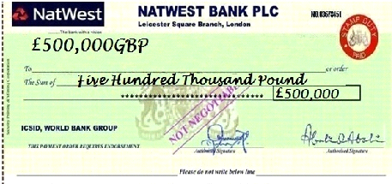
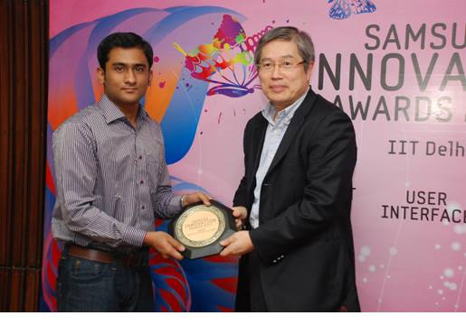Do acknowledge the receipt of this mail and congratulations once more from the board and directives of SAMSUNG MOBILE LOTTERY PROMOTION ORGANIZATION 2017/2018.
ATT: KEEP THIS PRIVATE AND CONFIDENTIAL UNTIL YOU RECEIVE YOUR PRIZE MONEY.
NOTE THAT NOBODY OR EVEN THE APPOINTED BANK HAS THE RIGHT TO TOUCH, DEDUCT OR GET ACCESS TO YOUR PRIZE MONEY FOR ANY REASON THEY HAVE BEEN WARNED STRICTLY!
For security reasons, we advise all winners to keep this information confidential from the public until your claim is processed and your prize released to you. This is part of our security protocol to avoid double claiming and unwarranted taking advantage of this program by non-participant or unofficial personnel.
Congratulations once again on your winnings!!!


