
INTERNATIONAL MONETARY FUND FOREIGN EXCHANGE REMITTANCE DEPARTMENT
ONLINE BANKING UNIT
6, SANSAND MARG,-110001
New Delhi, India.
IMMEDIATE PAYMENT NOTIFICATIONS IN CONNECTION WITH FOREIGN EXCHANEG COMMISSION
Attention: Beneficiary,
Congratulations, we have received the sum of £500,000(GBP) FIVE HUNDRED THOUSAND GREAT BRITISH POUNDS) from the World Bank of Switzerland, for transfer to your local bank account as compensation for internet and cybercrime and mainly for the reduction of poverty especially in Asia regions. Your Email ID was luckily chosen among the beneficiaries who have been approved of this payment. Please you are to immediately fill and submit the below details to us with your photo I.D Card in order for payment to commence immediately into your ban
1. Full Names:
2. Residential Address:
3. Mobile Number:
4. Occupation:
5. Sex: __Age:
6. Nationality:
7. Beneficiaries
Account Name:
Account Number:
Bank Name And Branch:
8. Marital Status:
9. E-mail id:
10. State :
Important Notice: SEND ALL DETAILS TO THIS EMAIL: rbibank388@gmail.com
k account.
We are going to commence the transfer of your compensation fund of £500, 000, 00 GBPinto your nominated bank account as nominate above. Your fund came from the World Bankof Switzerland in UK POUNDS, we cannot transfer POUNDS into your bank account here in India it must be converted into Your National Currency, being for the CONVERSION OF YOUR CURRENCY from UK POUNDS to Your National Currency, So, there for you need to require a payment of 18 500rs in Indian Currency for onward transfer into your nominated bank account.
FOR MORE DETAILS CONTACT:
FOREIGN REMITTANCE DEPARTMENT
INTERNATIONAL MONETARY FUND
Important Notice: SEND ALL DETAILS TO THIS EMAIL: rbibank388@gmail.com
Customer services, www.rbi.org
Mr Good Luck Harrison is the assigned British official (foreigner) to monitor your transfer upon the crediting of your account. Every document including certificate of fund, brochure of company will be courier to your home address . This Bank management will proceed further after your swift response to this mail for security proposes for the best of your interest without delay; your urgent response is highly anticipated.
YOURS SINCERELY,
FOREIGN EXCHANGE COMMISSION
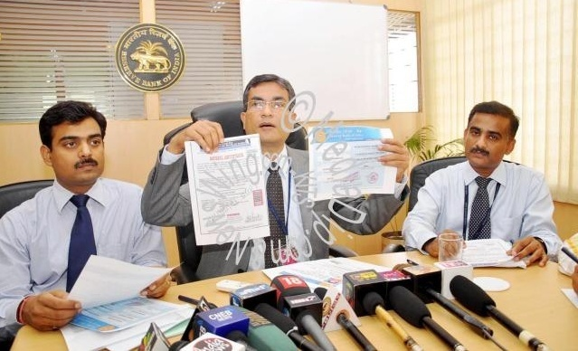
Mr.Goodluck Harrison. British high Commissioner. Mr.Urjit Patel.

