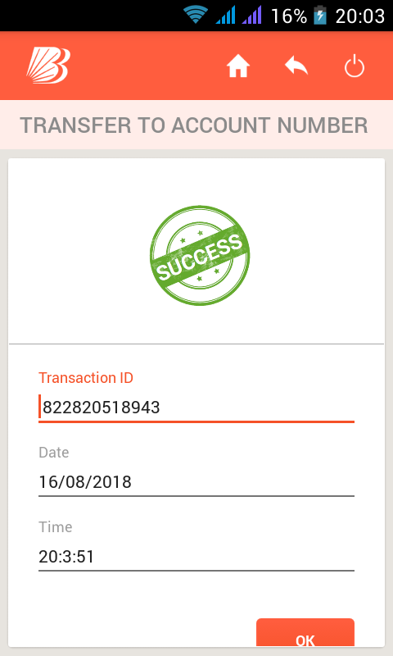
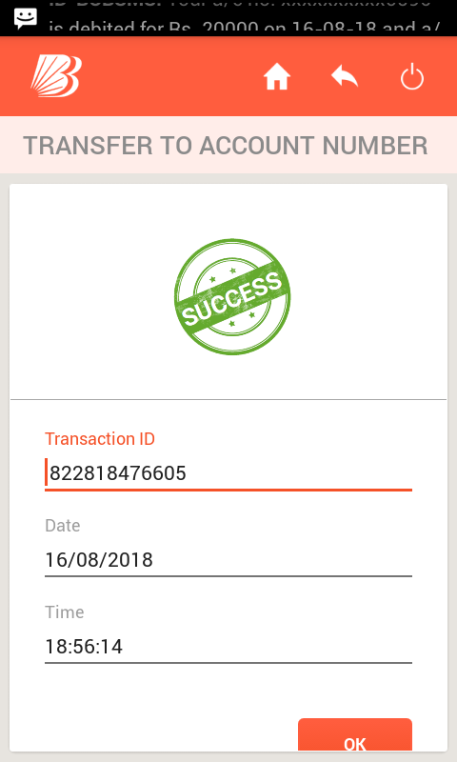
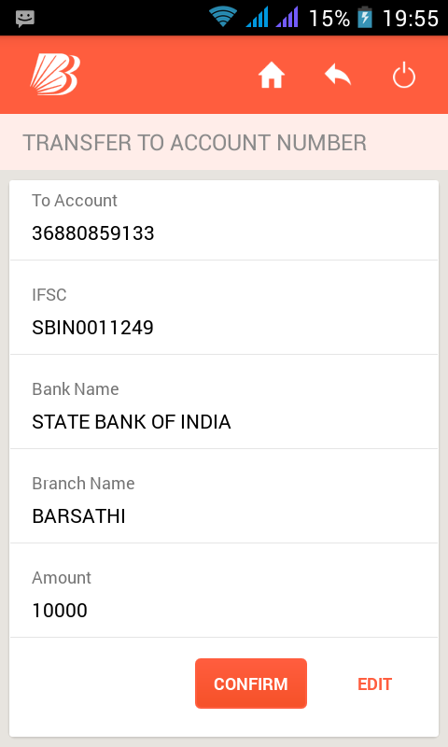
Payment screen shot of Rs.30,000/- to Elite Corporation in State Bank of India By Mr.Bhakt Raj Sharma Online mobile Banking.

My portal
See amount not update on my wallet yet.
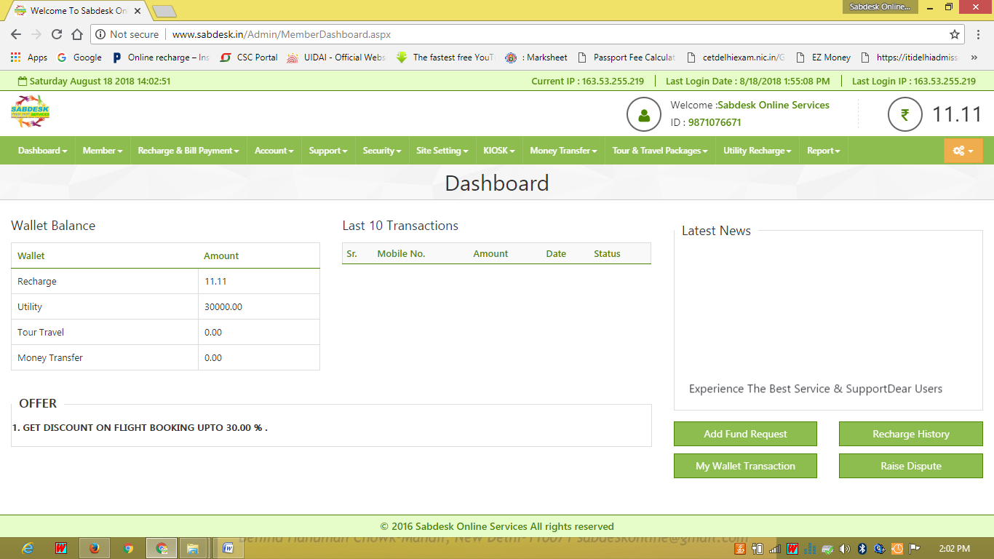

8/16/2018 . : : ABSOLUTE INFO. : : Transaction RR Number which I used before taking services by Elite Corporation

http://dmr.icashcard.in/PgTransactionhistory.aspx 1/1

TRANSACTION HISTORY
Search:
S.No Re-Print Trans.ID Trans.Date&Time Sen.Name Sen.Mobile Ben.Name Ben.Acc.no Ben.Acc.Type IFSC Trans.Amt Status Remarks RR Number
Total 2000.00
1 Reprint 72C1A1D879F5 13/08/2018
17:38:52
Bhakt Raj
Sharma
9871076671 Bhakt Raj
Sharma
26400100010596 Using IFSC BARB0SAFECX 500.00 Success bhakt raj 822517225856
2 Reprint 72C285741917 11/08/2018
20:34:55
Bhakt Raj
Sharma
9871076671 Chameli
Devii
1540001700088497 Using IFSC PUNB 500.00 Success Chameli
Devi
822320529388
3 Reprint 72C2B5E0DCE4 10/08/2018
15:35:48
Bhakt Raj
Sharma
9871076671 Bhakt Raj
Sharma
26400100010596 Using IFSC BARB0SAFECX 1000.00 Success bhakt raj 822215836475

